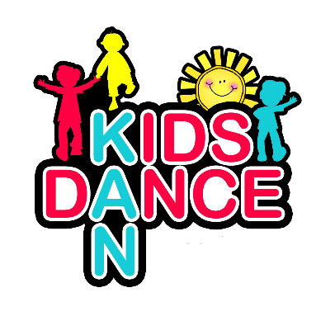 | How to Order  1 – Complete Order Form  2 – Send order form back to Kids Kan Dance via email  3 – Kids Kan Dance will confirm receipt of order and confirm total cost back via email  4 – Make bank transfer for Total Cost  5 – Email Kids Kan Dance to confirm transfer made  6 – Kids Kan Dance will advise of aprox. order deliver date  7 – Order will be bought to class, any returns or swaps are done free of charge.  No orders will be made without full payment  Orders are placed once a month

Uniform Order Form
Item | Quantity | Size | Price
TOTAL PRICE

